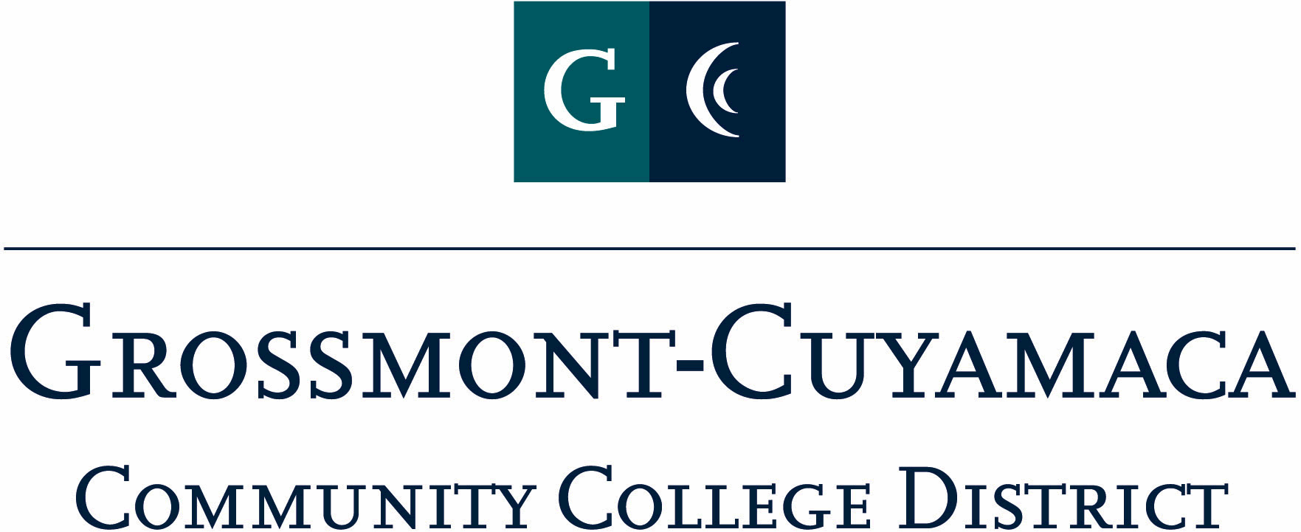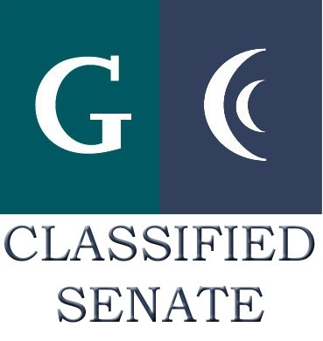
CLASSIFIED SENATE
EXECUTIVE BOARD MEETING
June 2, 2009– Meeting Minutes

Members Present: Debi Miller (vm), Rocky Rose, JacQueline Osborne (vm), Paula Tillery (vm), Lynne Davidson (vm), Maggie Gonzales (vm), Pat Murray (vm), Shari Ball (vm), Patricia Bailey
Guest: Scott Howell

1. Welcome and Call to Order: The meeting was called to order at 12:09p.

2. Approval of Minutes from 12/1/2008: Since quorum was not met at the May 5, 2009 meeting, the minutes will be posted on the website for information only.

3. Appoint & Ratify Executive Board Offices for 2009-2011

The President, Debi Miller, appointed the following staff to vacant positions not previously filled by nominations: Paula Tillery for Treasurer, Avelina Wilder for Cuyamaca College Senator, JacQueline Osborne and Angela Johnson for GCCCD District Senators.

A motion to ratify the appointed and nominated Executive Board members was proposed. M/S/A Rose/Ball. The motion was approved with a vote of seven in favor, none opposed and no abstentions.

4. New Business: The President, Debi Miller, suggested that the July E-Board meeting be held on July 14th due to the 4th of July holiday. After a brief discussion, a motion was brought forward. A motion to hold the July E-Board meeting on July 14th was proposed. M/S/A Murray/Rose. The motion was approved with a vote of seven in favor, none opposed and no abstentions.

5. Communication

VP Reports

District: Paula Tillery, Vice President for the District reporting that the district is working on the budget and a $10 million reduction is anticipated. All staff is encouraged to send their ideas for budget reductions to the Chancellor. The tentative budget will be presented at DEC/DSP&B on June 8th and a Governing Board Budget Workshop is scheduled for June 9 and action will be taken by the Governing Board at the June 16 meeting. She added that the district is offering an Early Retirement Incentive and any interested staff member that has questions two PERS meetings are being held: One on 6/1 at Cuyamaca and on 6/2 at Grossmont.

Grossmont: Pat Murray reported that the Leadership of Classified Senate and CSEA will be offering flex week employee orientations. The President of Classified Senate and President of CSEA will be meeting with the college president’s to discuss rotating this orientation between the campuses (GC in Fall and CC in Spring). The VP at Grossmont, Pat Murray, is working directly with the Grossmont president, Dr. Cooke, to formalize the power point presentation for this orientation. The power point gives an overview of the leadership at the college and state levels.

P. Murray further commented on the recent Budget & Planning Committee meeting to including cutting sections at the college to make tentative budget work. The recent decision to drop students for non-payment district-wide extracted approximately 1300 students from the system. There is enrollment evidence that more that ½ half re-registered.

P. Murray also reported that Dave McDade and Will Pines were recognized at the general commencement ceremony as classified representatives. This is significant because having support staff acknowledged at graduation is a new element of the ceremony.

Debi Miller explained that classified leader meetings will alternate campuses and that meetings at Cuyamaca would be represented by Jan Recktenwald and Cheryl Houston for CSEA, and Debi Miller and Maggie Gonzales for Classified Senate; when at Grossmont, CSEA representatives would be Nick Comer and Kasi Althaus, and Senate representatives Pat Murray and Paula Tillery (as of July, Wendy Corbin will replace Paula Tillery).

Pat reported on the May 18, 2009, Classified Leaders meeting with the Chancellor. The meeting was attended by Comer, Althaus, Murray and Tillery. The leaders discussed the past history of Classified Leaders meetings with the previous Chancellor, the relationship between CSEA and the Senate, and various issues of interest to CSEA and the Senate including the difference in staff development participation between the two campuses, particularly during flex week.

The ice cream social to celebrate the support of classified staff for the “Students First” campaign by parking off campus last year was well attended and successful.

Cuyamaca: Maggie Gonzales reported that the drop for non-payment generated additional concerns for students both good and bad. Rocky Rose added that by Monday am 500 students had re-registered. Lynne Davidson added that the students could pursue exception through A&R if needed.

M. Gonzales added that the college is bracing for an influx of Chaldean refugees to be assessed and attend non-credit classes for the summer. She added that the foster youth program went well.

President’s Report: Debi Miller reported about the upcoming Retreat. She put out a request to 4CS for a presenter on Fundraising and a tentative meeting is scheduled with the VPs and the presenter on June 25.

Treasurer Report: Paula Tillery reported that the balance in the trust account is $1,761.00.

6. Continuing Business

CCSA Handbook (Final Read): Before approving the Handbook the group held a collegial discussion on how the scores would be sent to the E-Board. After discussion the President agreed to forward to all E-Board members an explanation on how to score the nominations, and how to fill out the Selection Plan score sheet. A motion to approve the CCSA Handbook was proposed. M/S/A Rose/Gonzales. The motion was approved with a vote of seven in favor, none opposed and no abstentions.

EEOAC/Diversity Plan Task Force: The President reported on the newly formed district-wide task force. This group will be charged with addressing the Accreditation Follow-up Report item for Grossmont College related to diversity in hiring policies across the district.

Bylaw 4.2.2 Update: This was a continuation of the discussion started at the last meeting. Pat Murray was tasked with bringing information forward to the group on this matter. Her research included pulling up Bylaws from the Academic Senate to see how they handle Senators voting in establishing a quorum. According to the Senate whatever Senator shows up to the meeting would be given the power to vote. P. Murray started the discussion with the group by considering a “proxy” vote. For instance, if a voting Senator is unable to attend the meeting that they would communicate to the President their intention for a “proxy” vote by another Senator. She referenced the Bylaw that indicates that only 2 Senators per site are given the voting privilege. When the discussion concluded, Debi Miller and Pat Murray were tasked with creating draft language to be brought back to the group for discussion at the next meeting. Pat said she would e-mail her ideas to the group.

7. Fundraising Activities: Rocky Rose reported on the Padres Fundraising activities. He explained that there were 30 tickets bought for the June 7 game and 12 were left. The President directed Lynne Davidson Davidson to compose an e-mail to be sent out to the membership about the remaining tickets. R. Rose also indicated that the Padres Sales office were able to take back some of the unsold tickets due to low fan turnout for the season. Overall, there was a net loss on this fundraising project. R. Rose will work with the Padres Sales office for next year’s fundraising project. The President indicated that this will be put on the Retreat agenda as a motion for consideration of approval by the E-Board.

8. Governance: Nothing to report.

The meeting adjourned at 1:00p.

